**PICNIC GAMES**

**Developer Guide**

|  |  |  |
| --- | --- | --- |
| **Faculty** | **Miss Neelam Malik** | |
| **Batch** | **2209B1** | |
| **Group** | **B** | |
| **Serial No.** | **Enrollment Number** | **Student Name** |
| 1. | Student1418143 | MUHAMMAD ALEEM |
| 2. | Student1407103 | MUHAMMAD UMAIR |
| 3. | Student1416155 | HARIB UDDIN |
| 4. | Student1424703 | ABDULLAH SHAZAD |

**Screenshots**

**Home page**

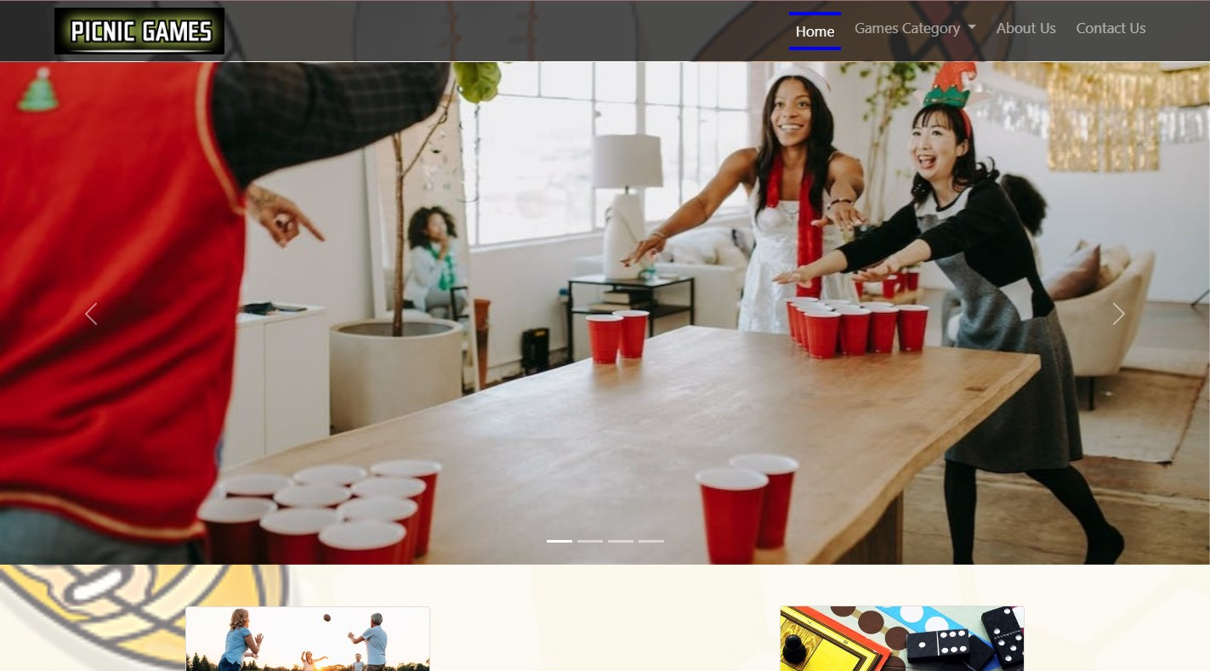

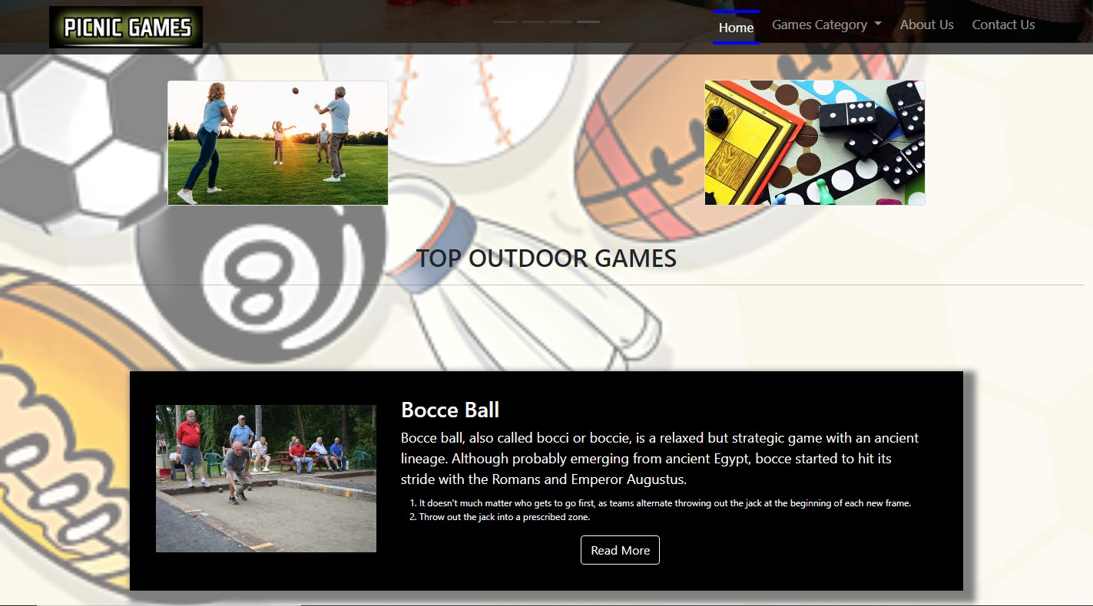

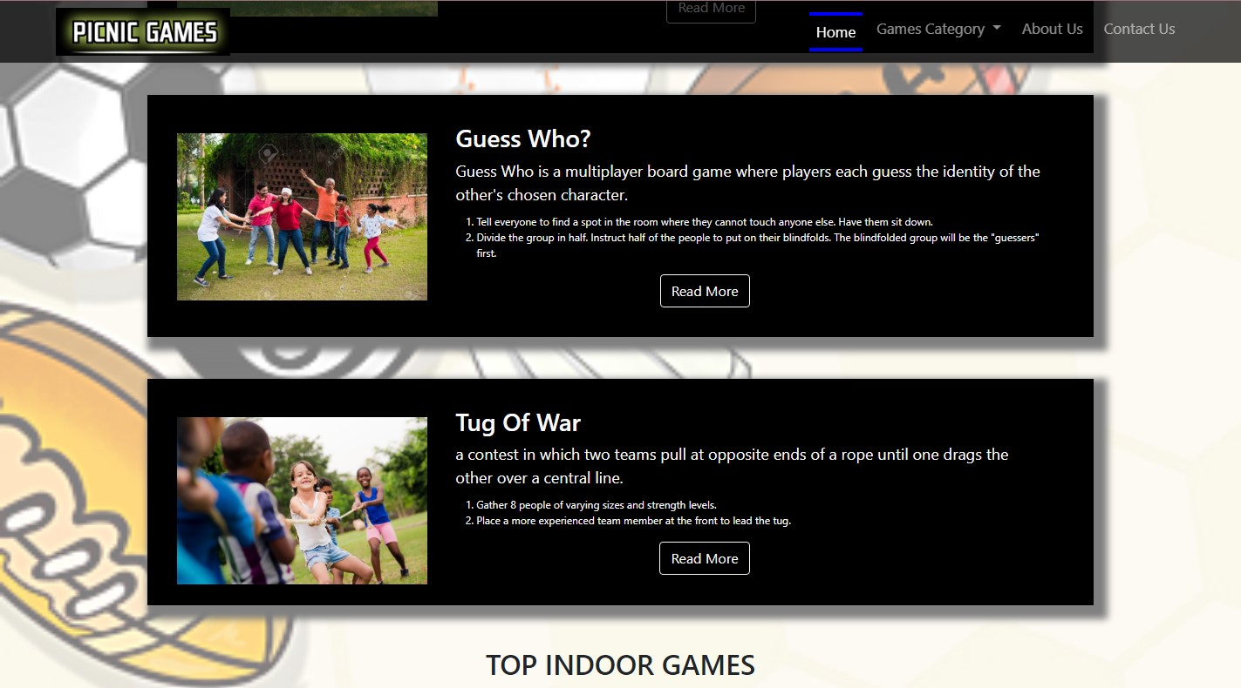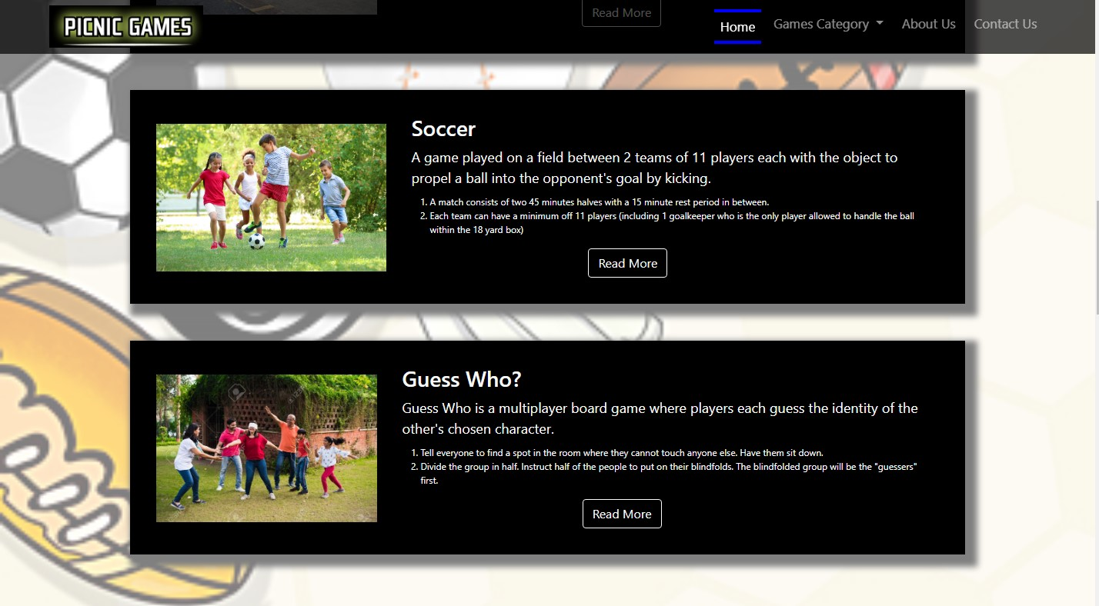

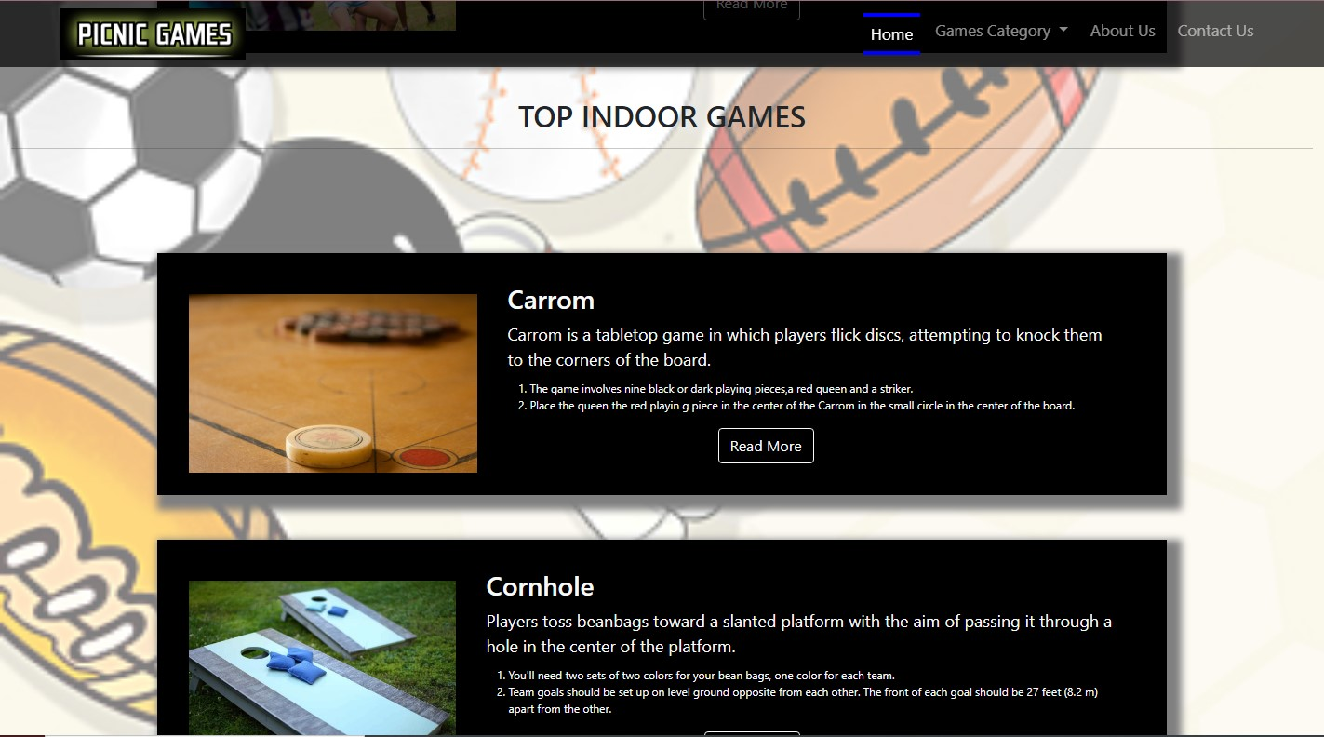

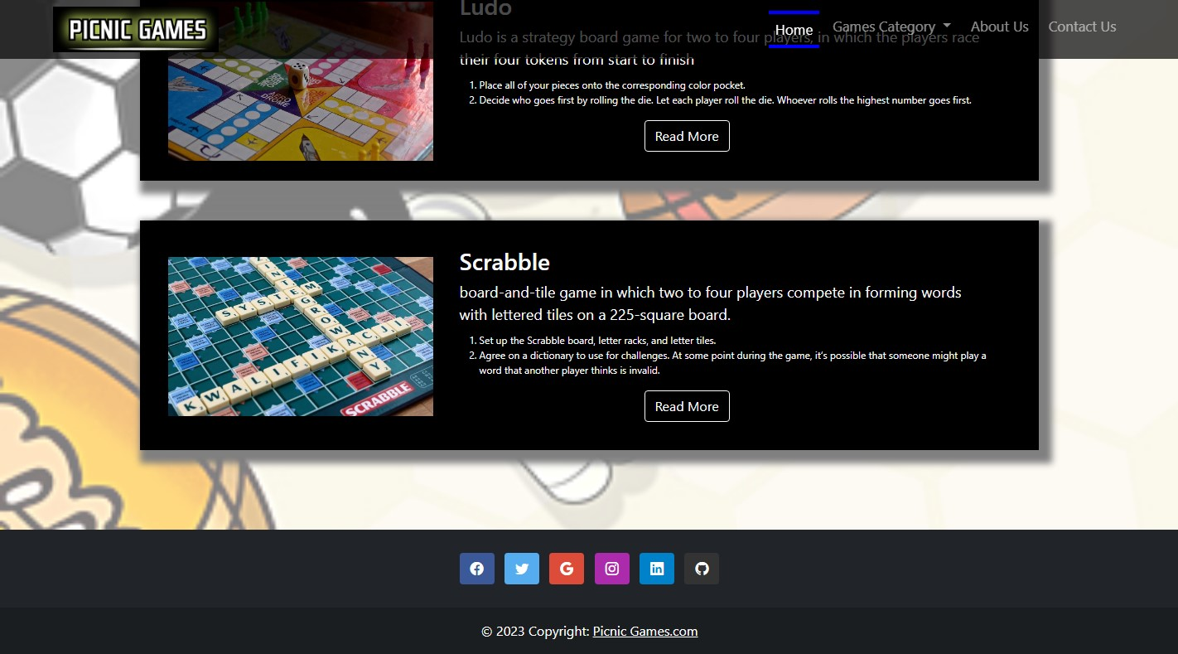

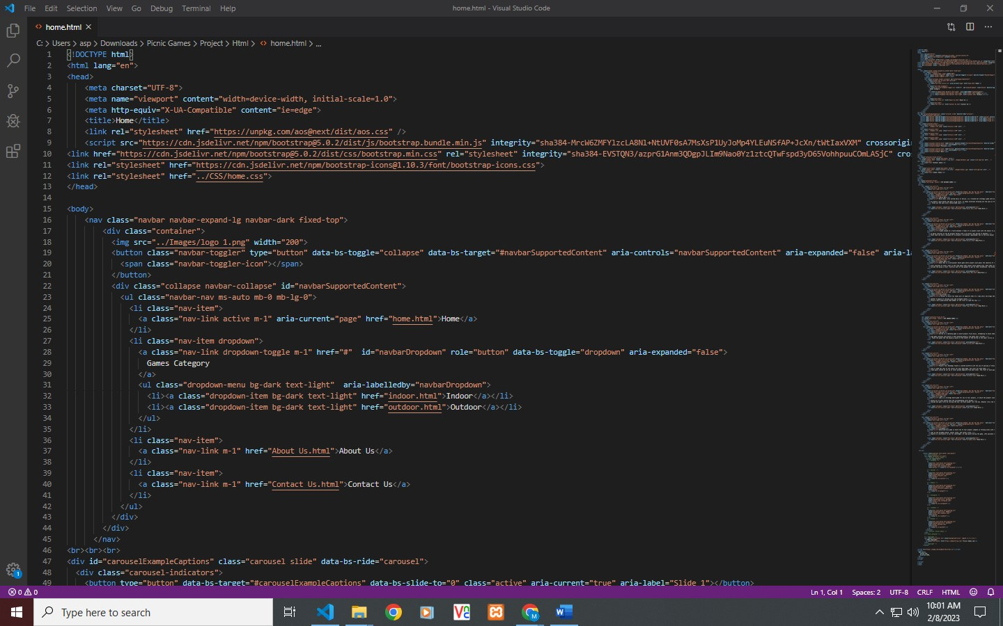

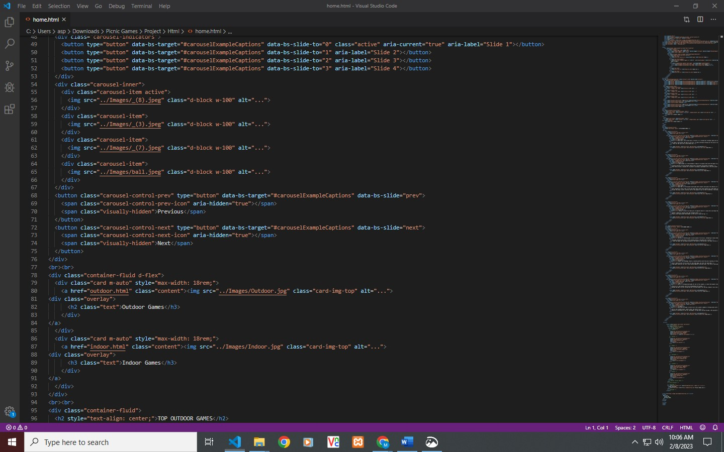

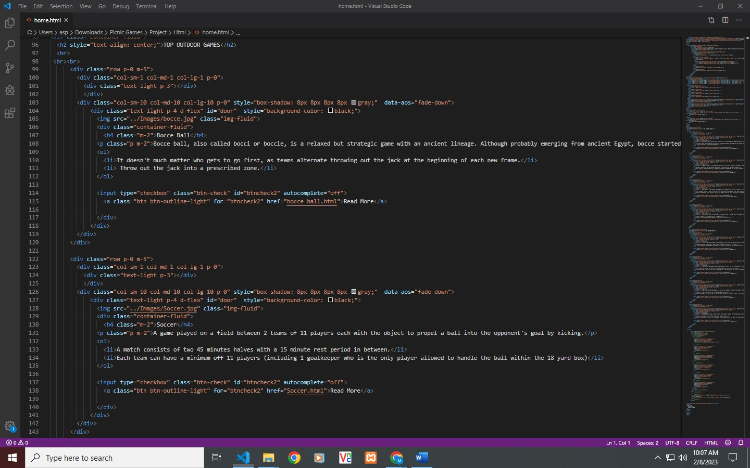

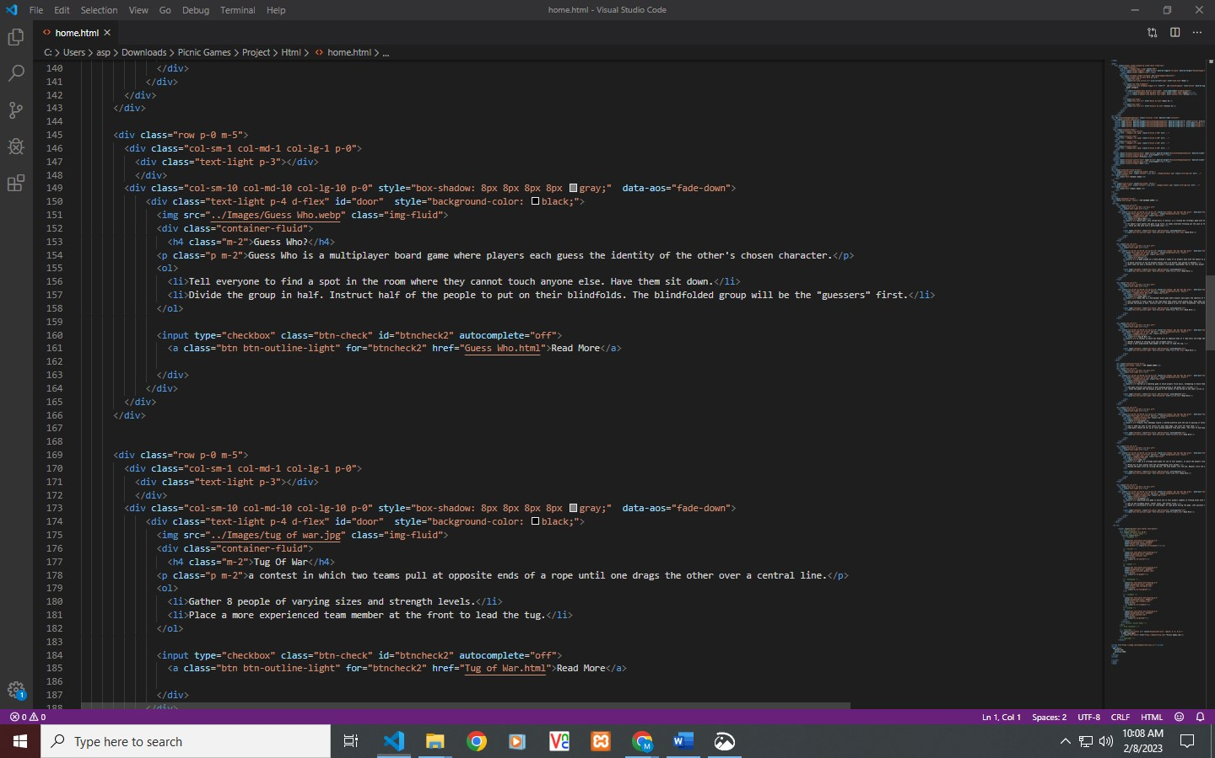

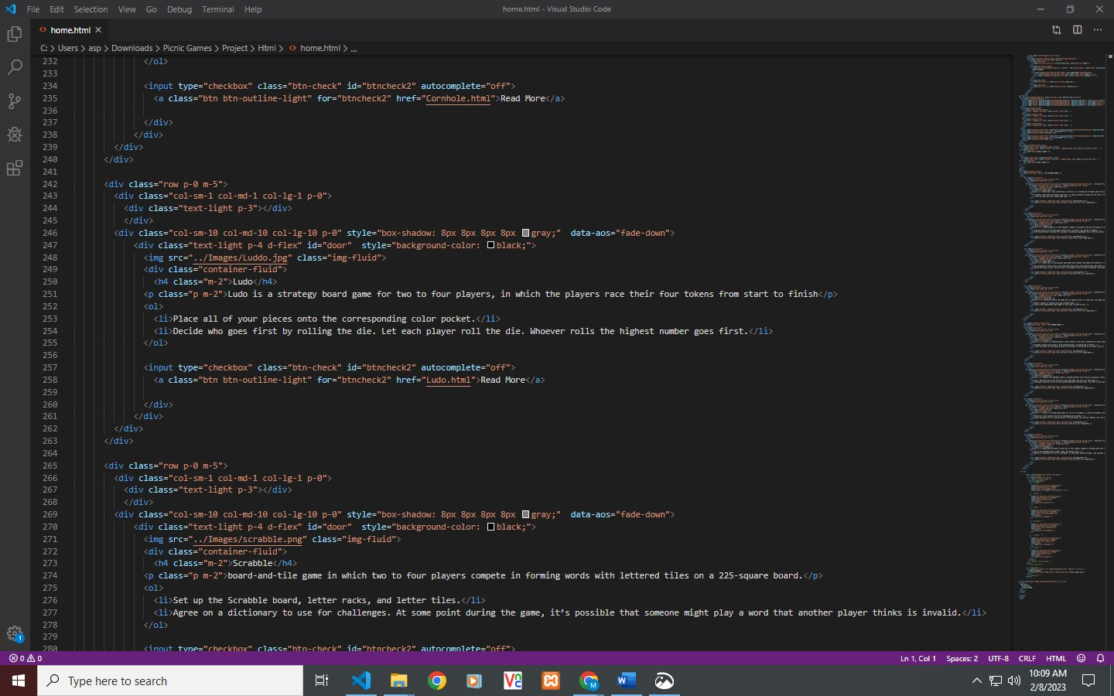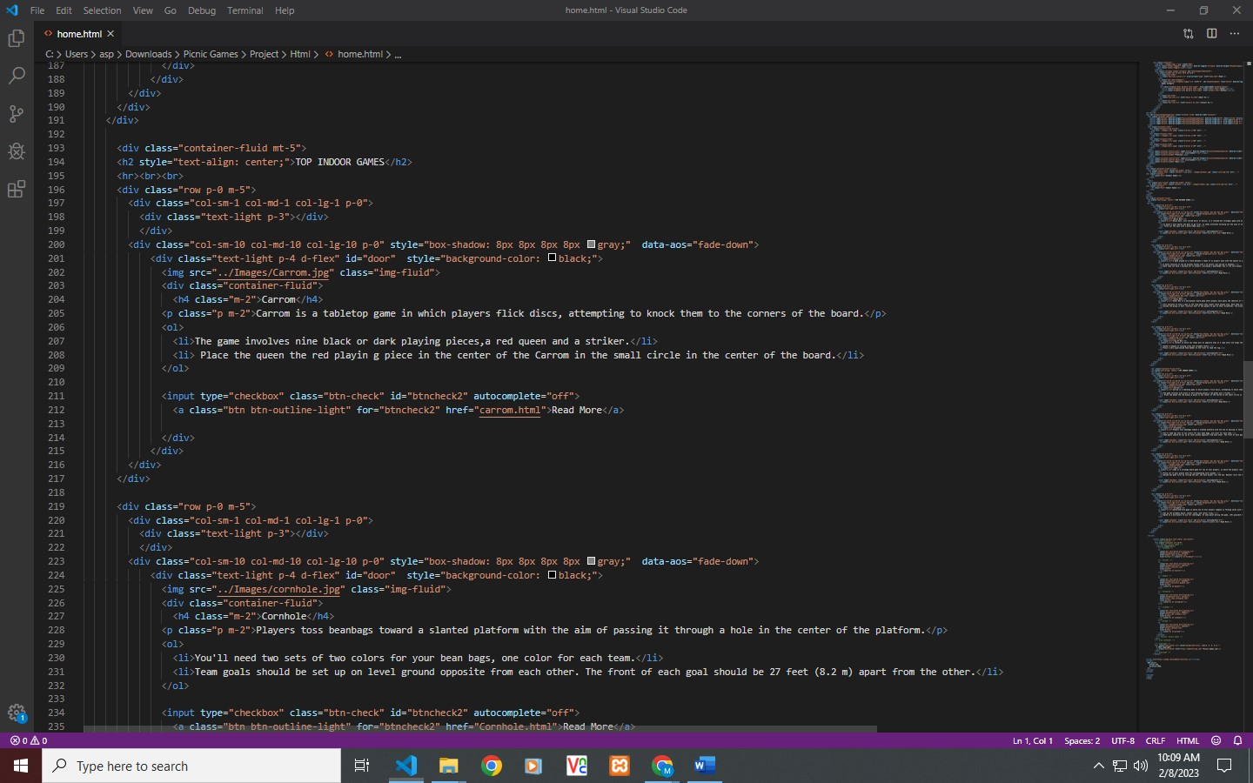

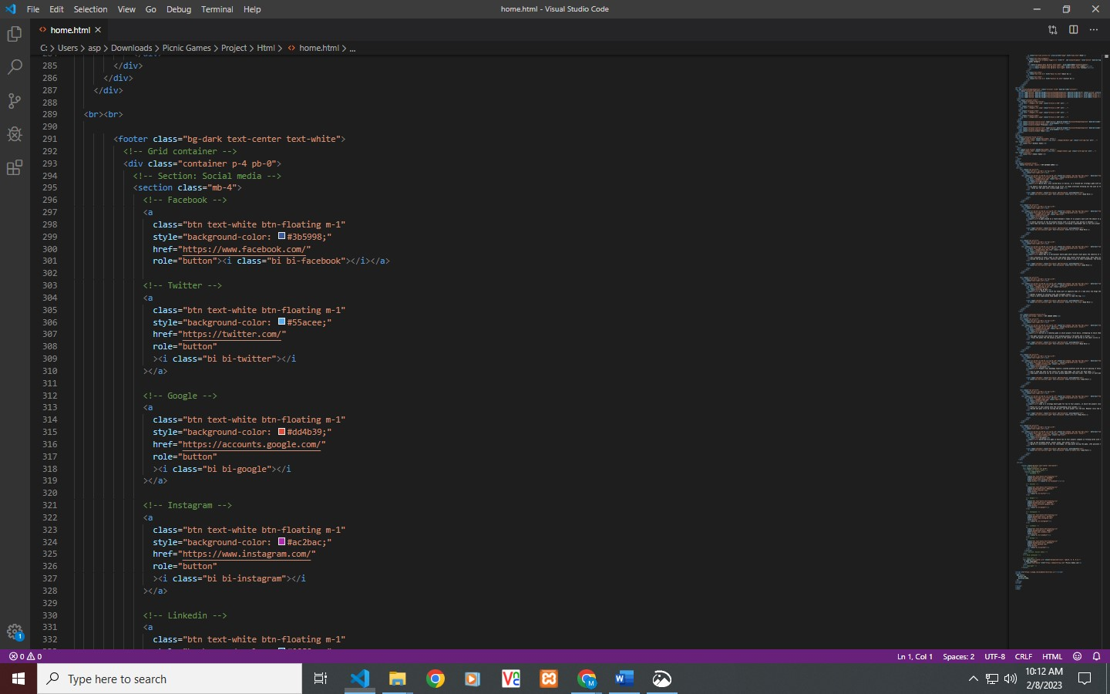

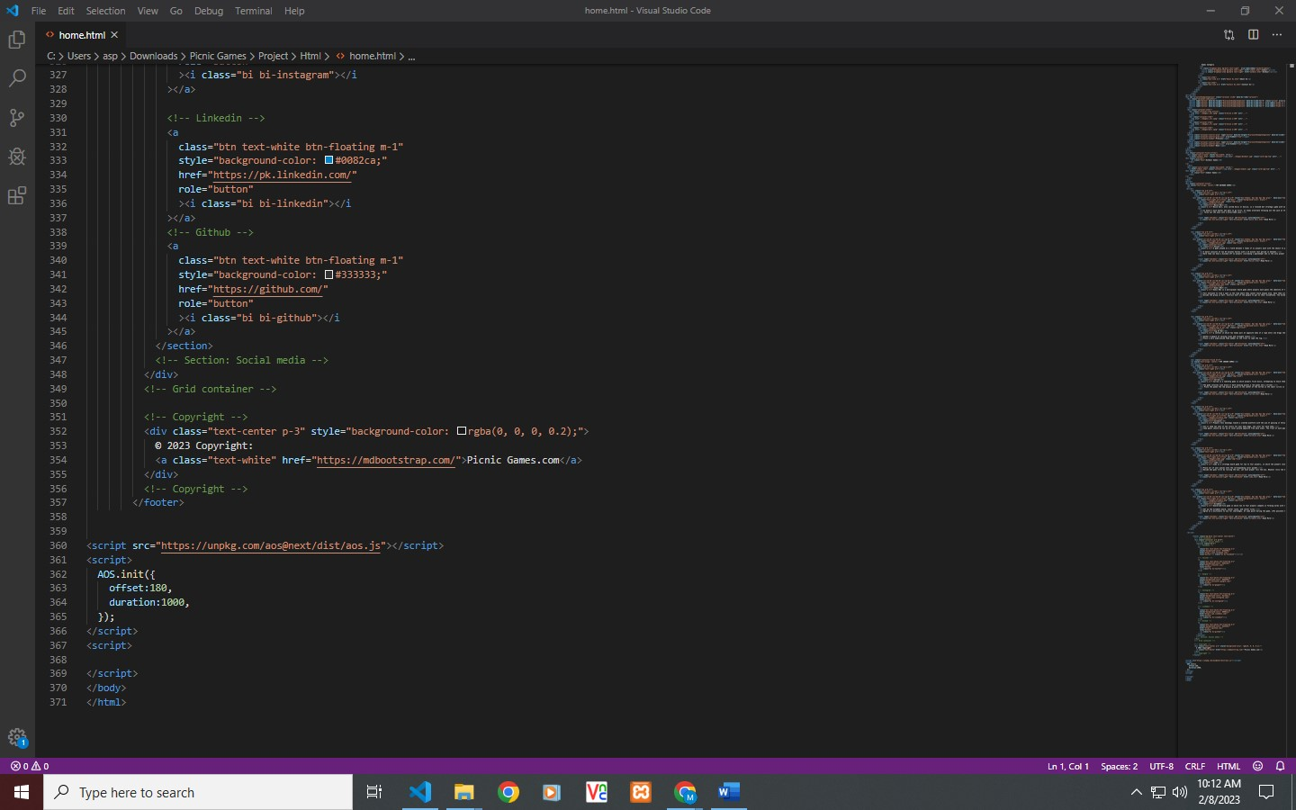

**Instruction Page**

1. **Indoor**
2. **Outdoor**

**Indoor Games**

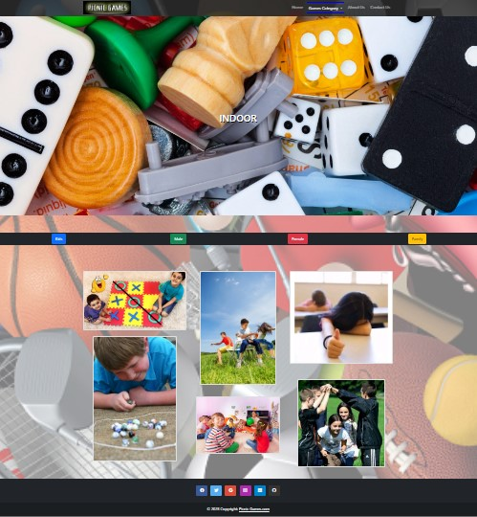

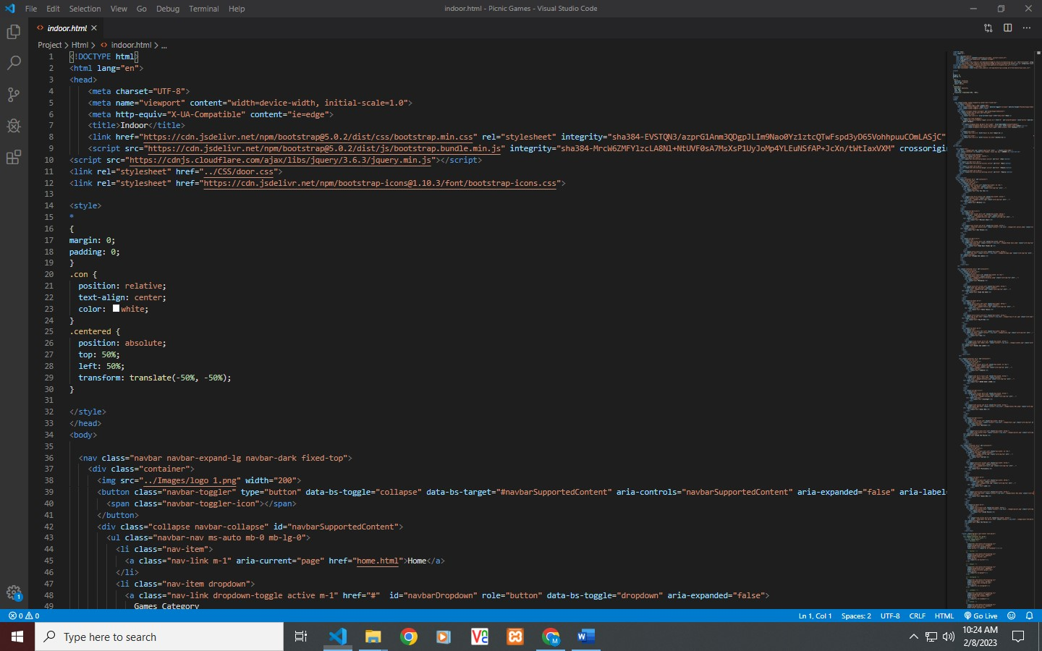

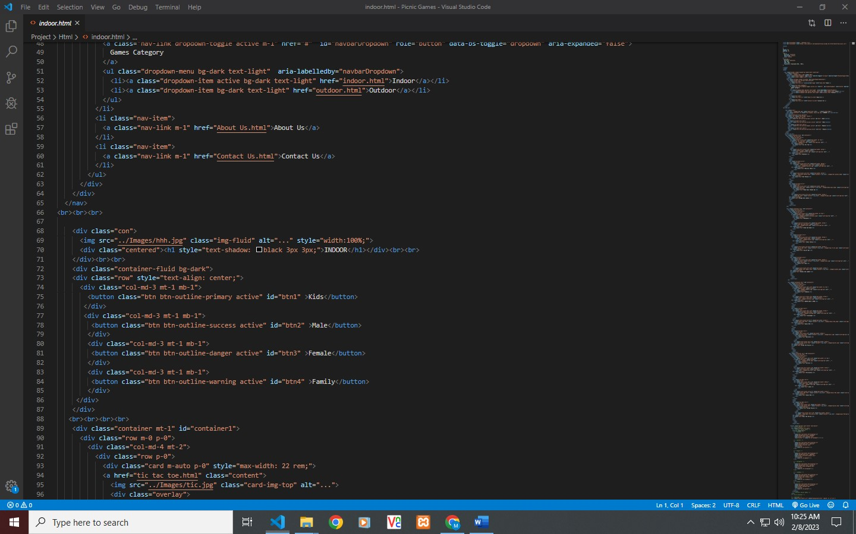

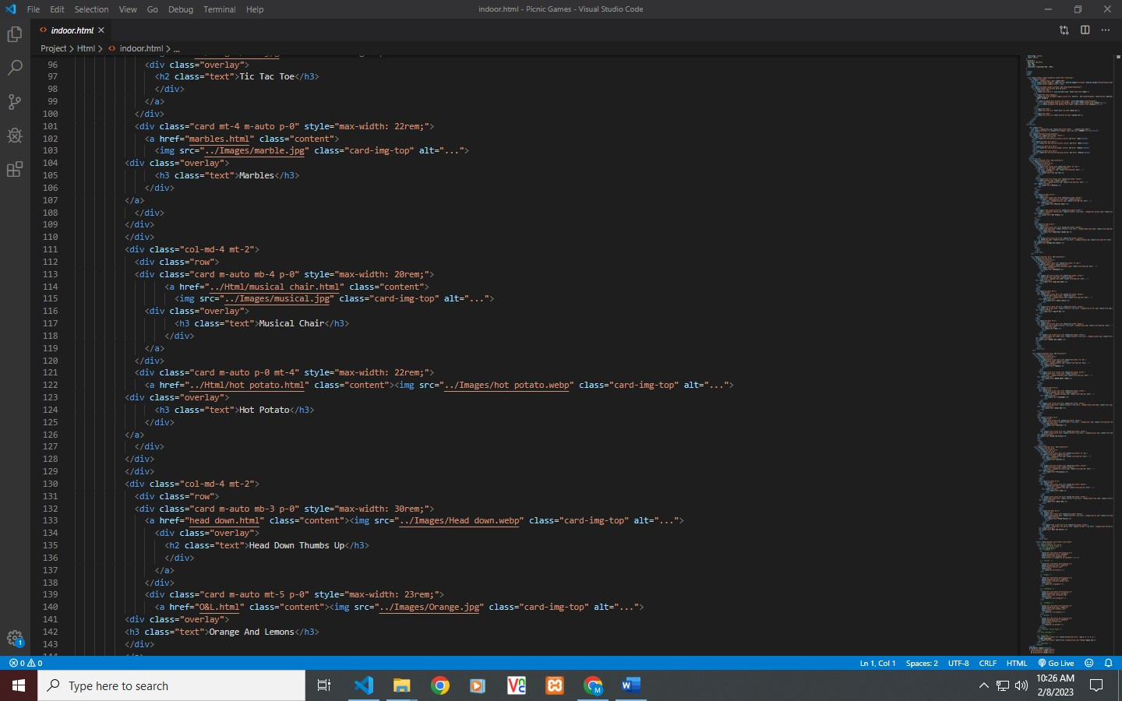

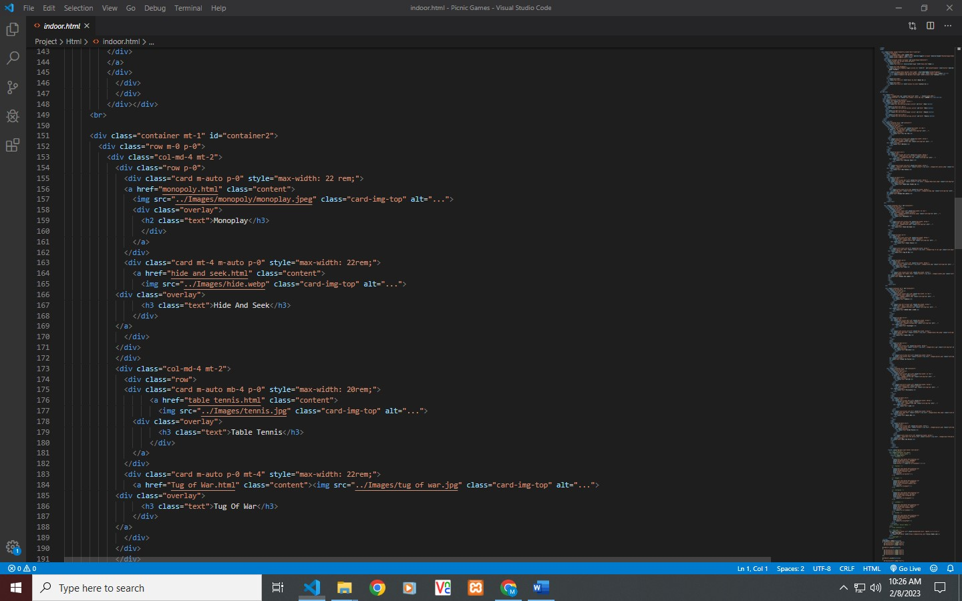

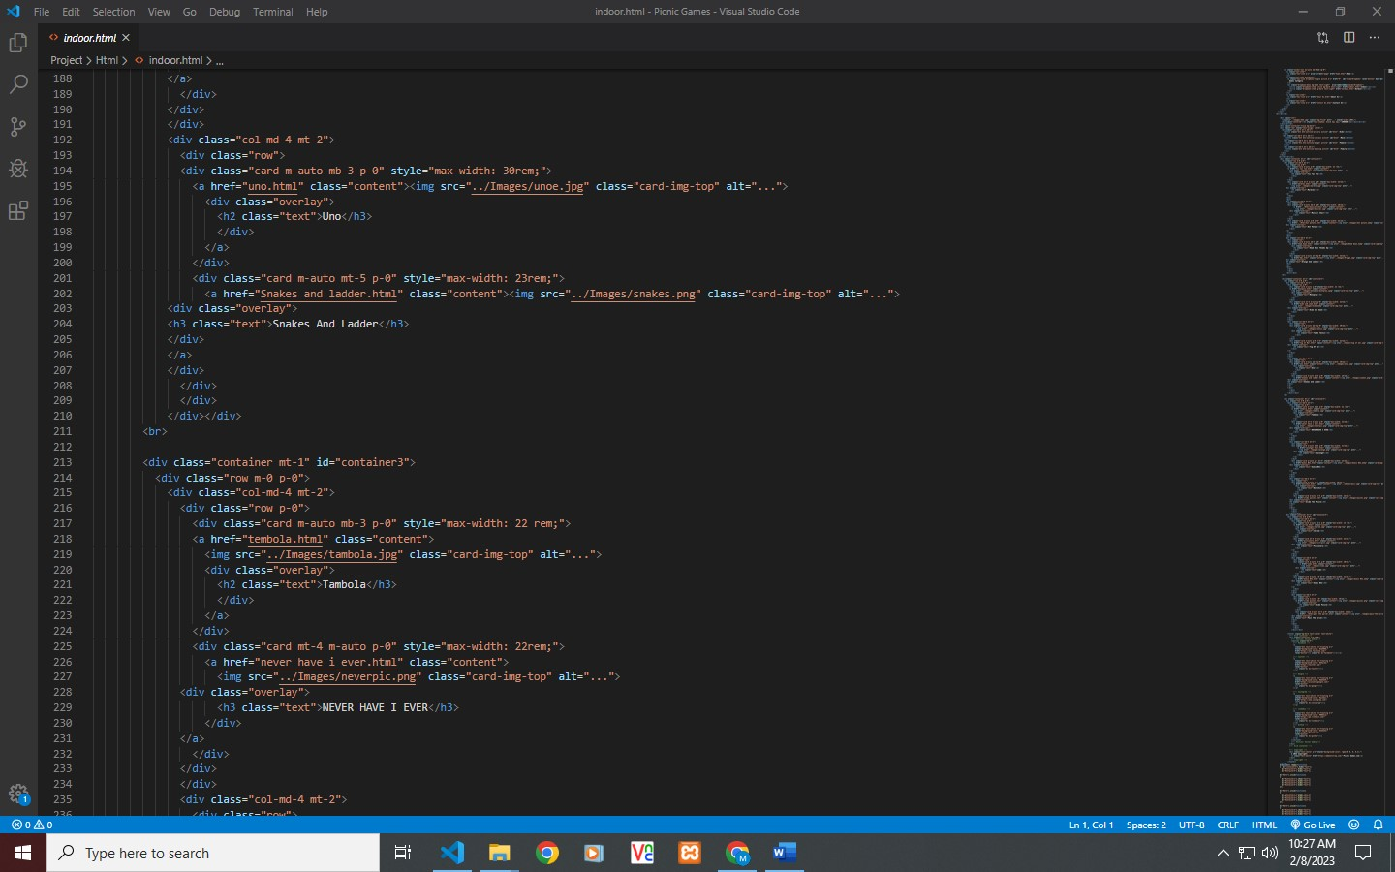

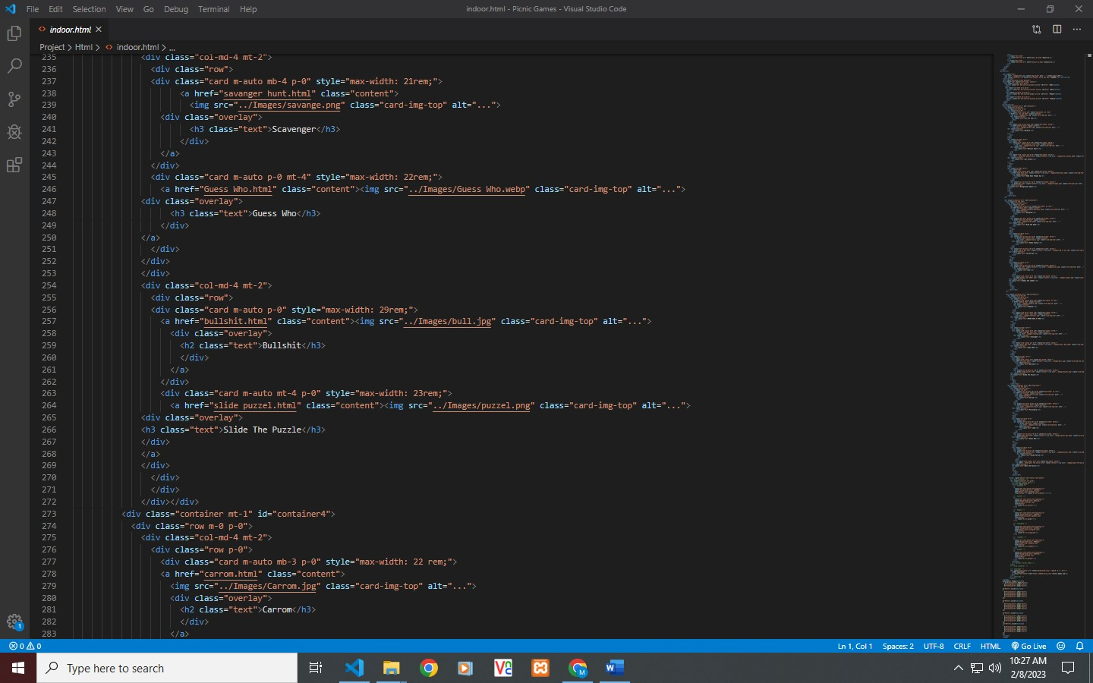

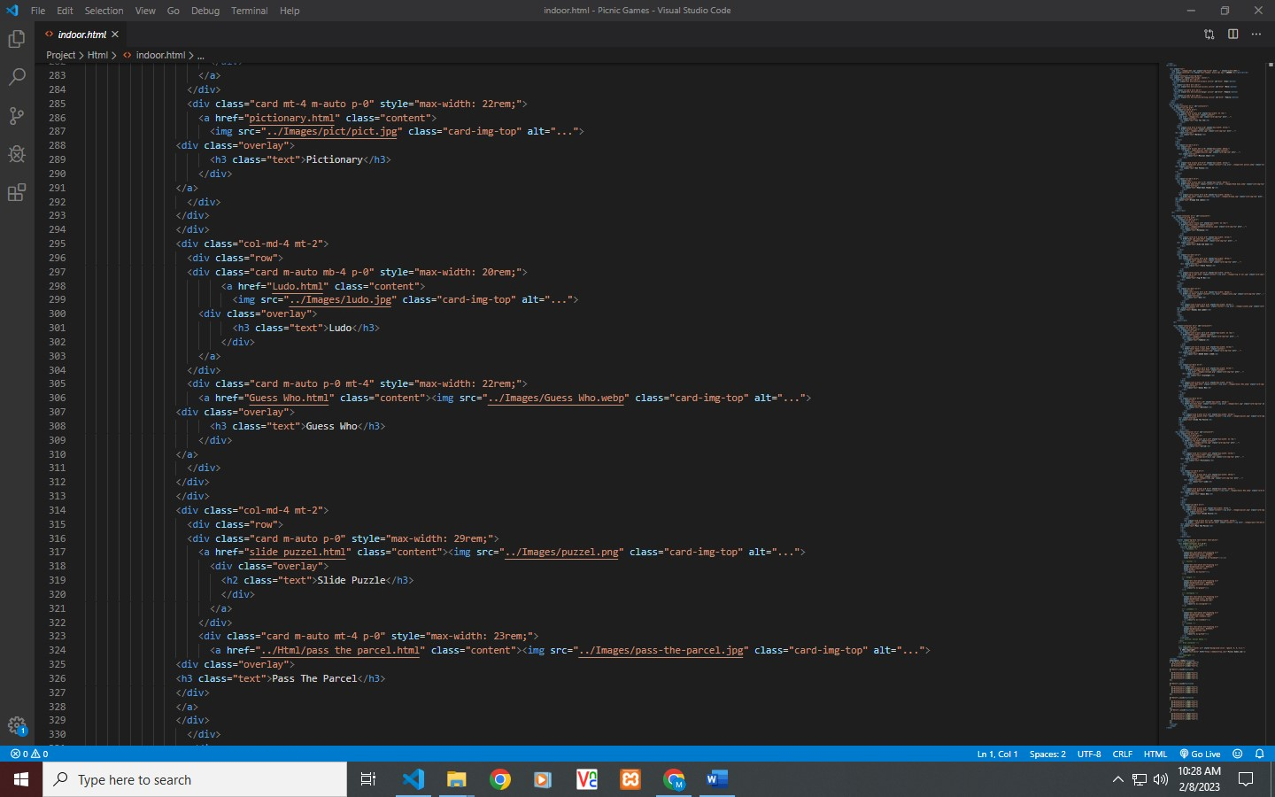

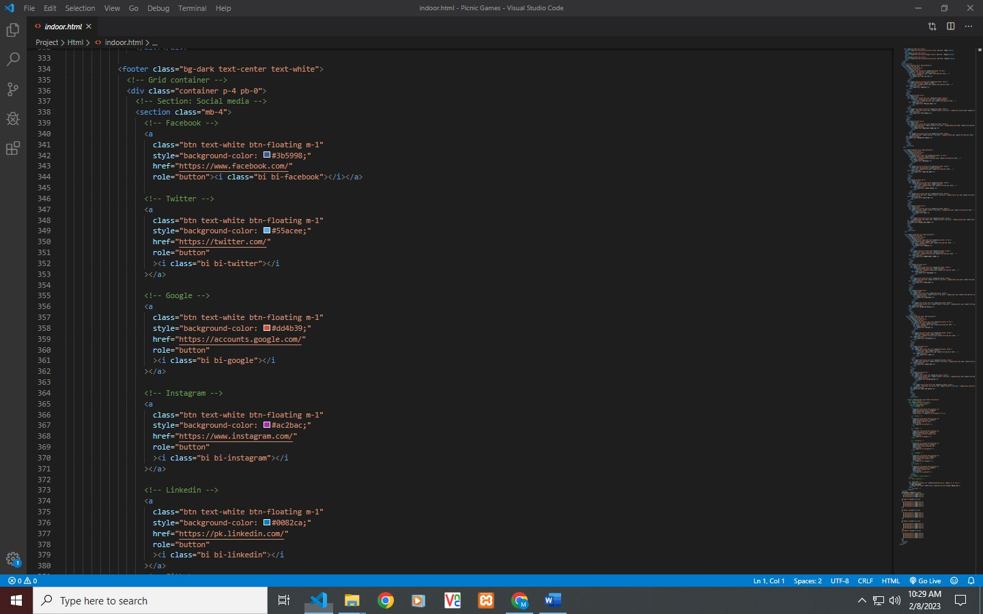

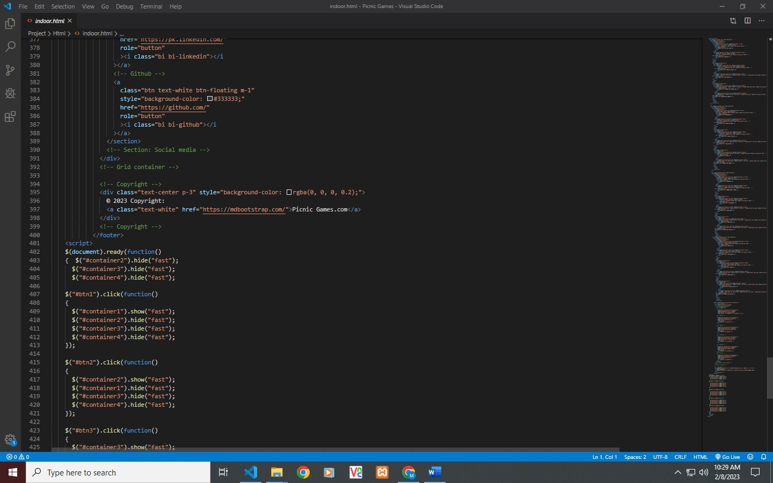

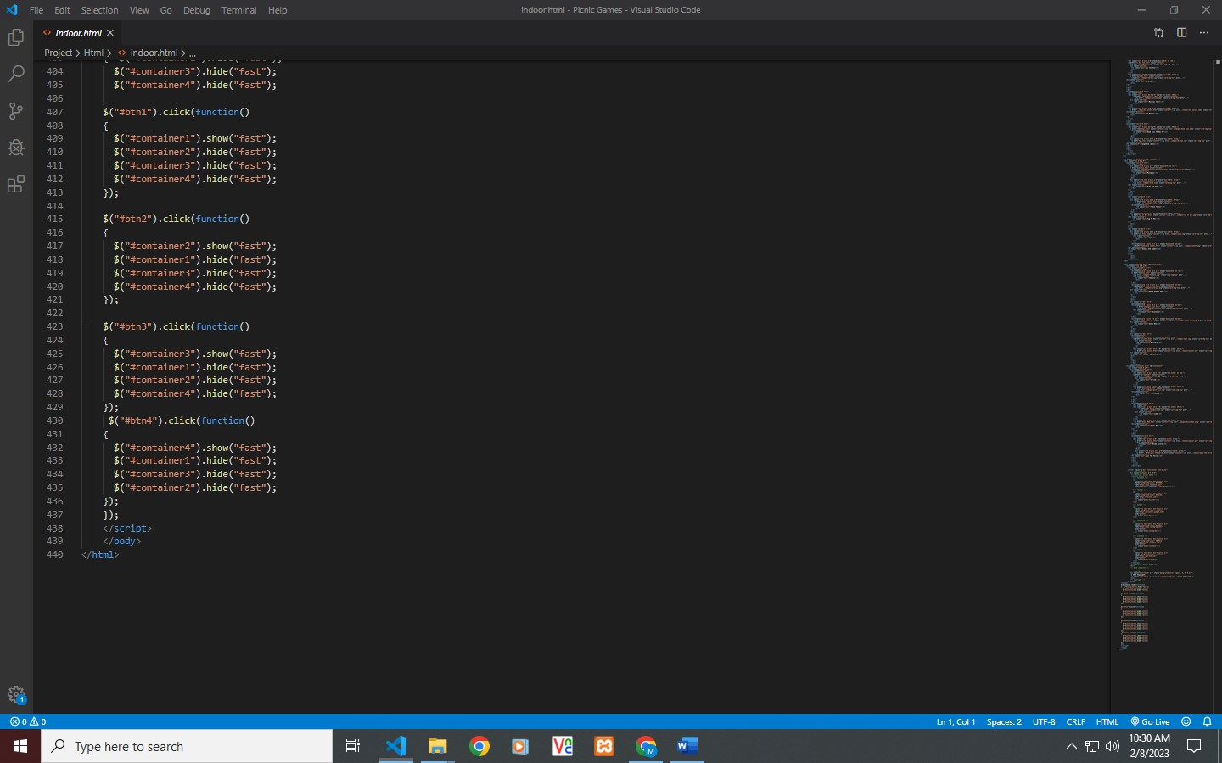

**Outdoor Games**

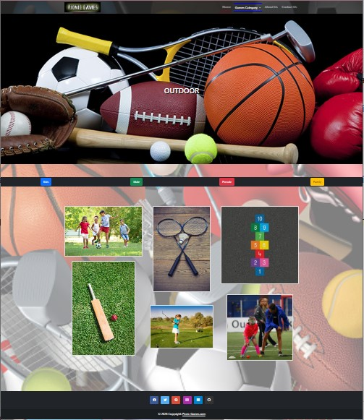

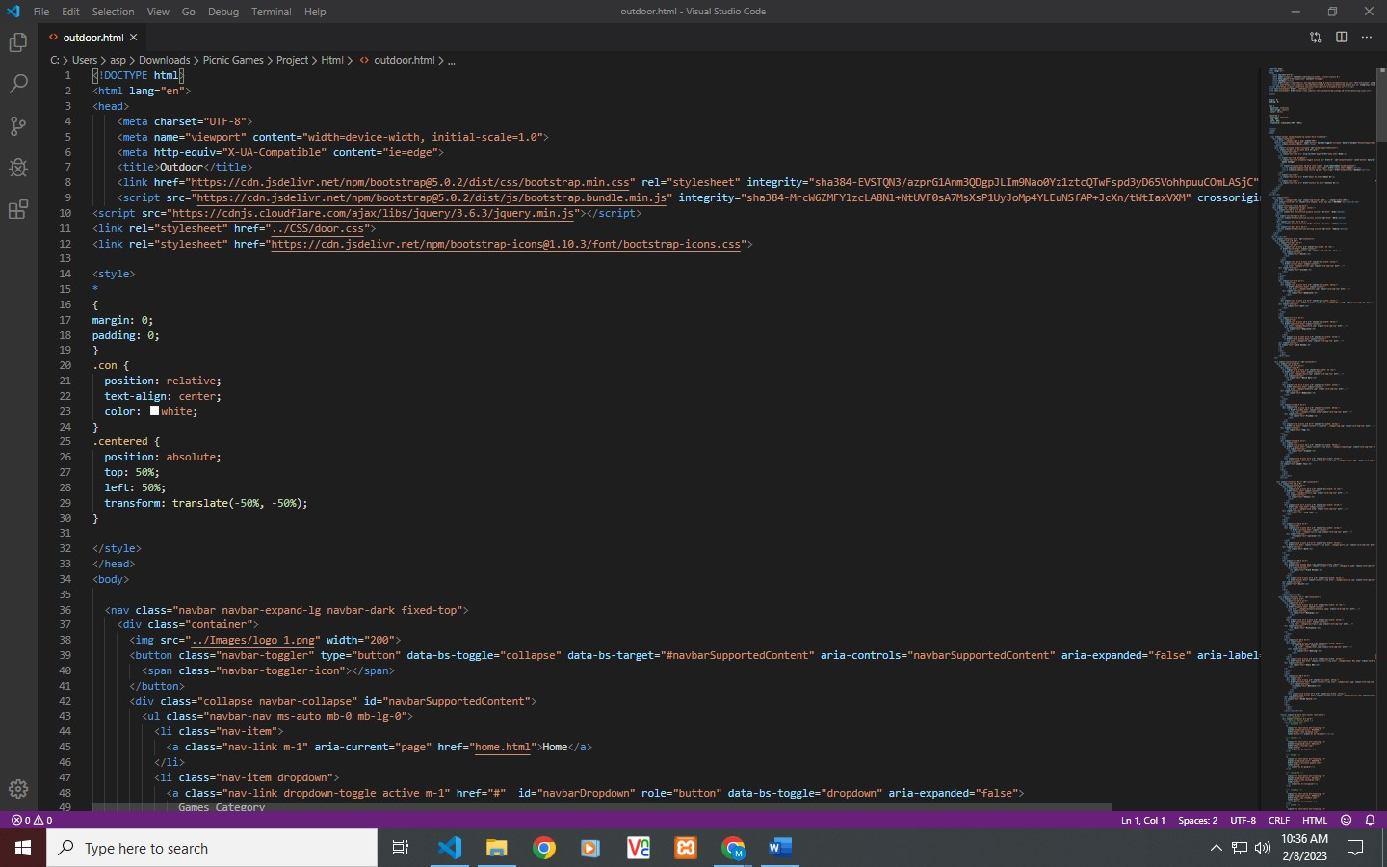

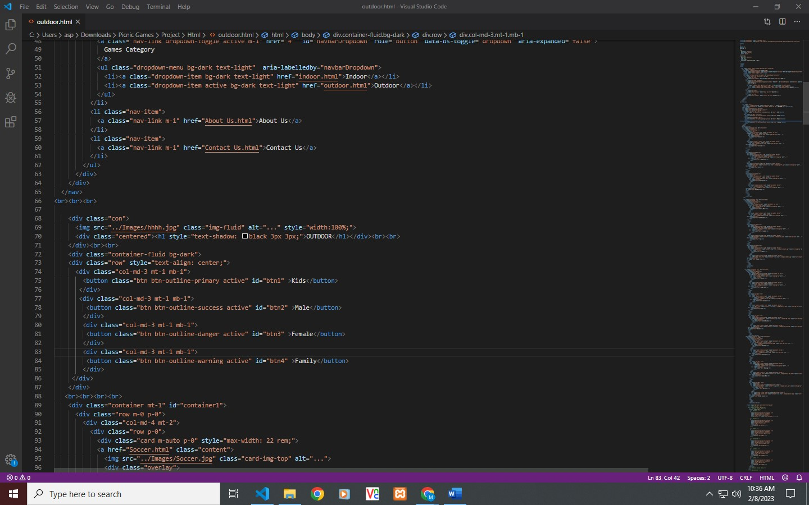

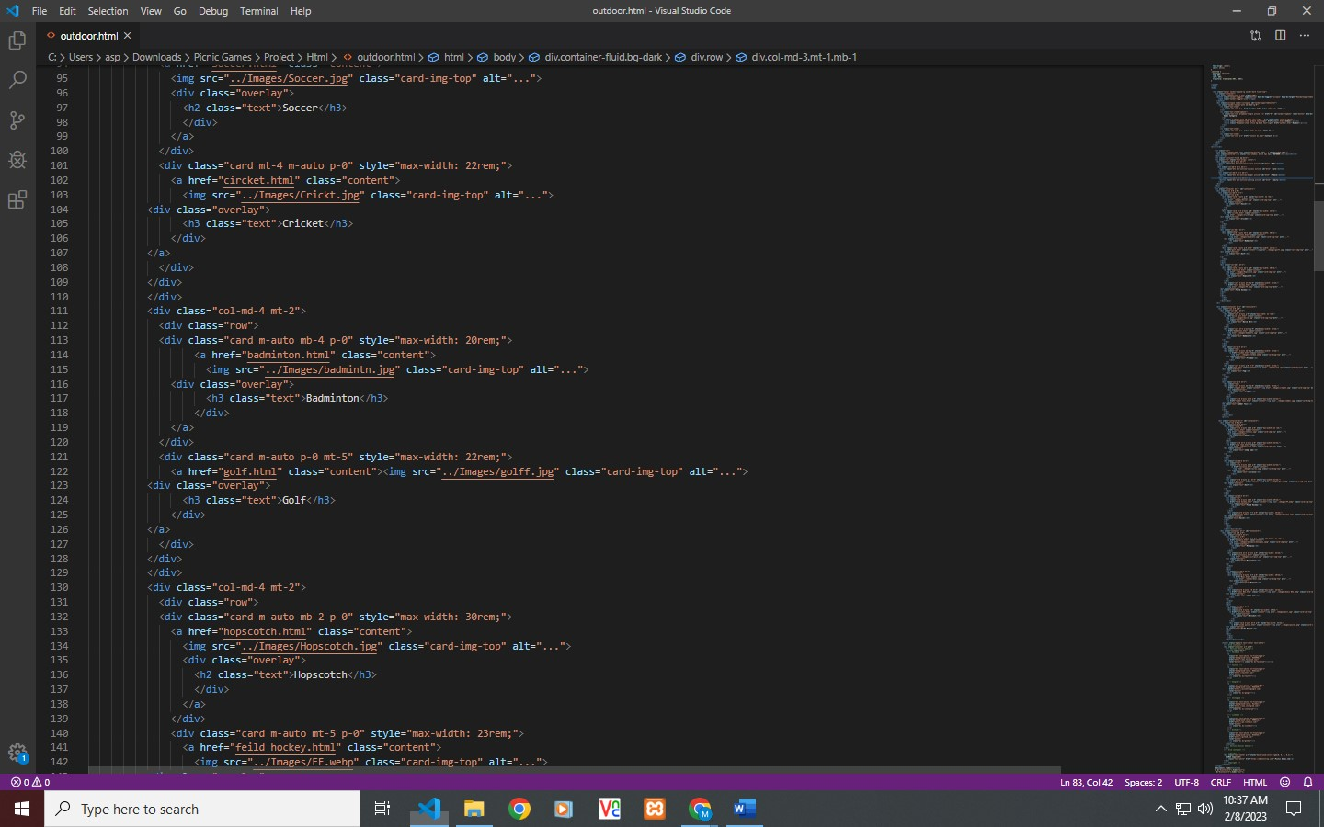

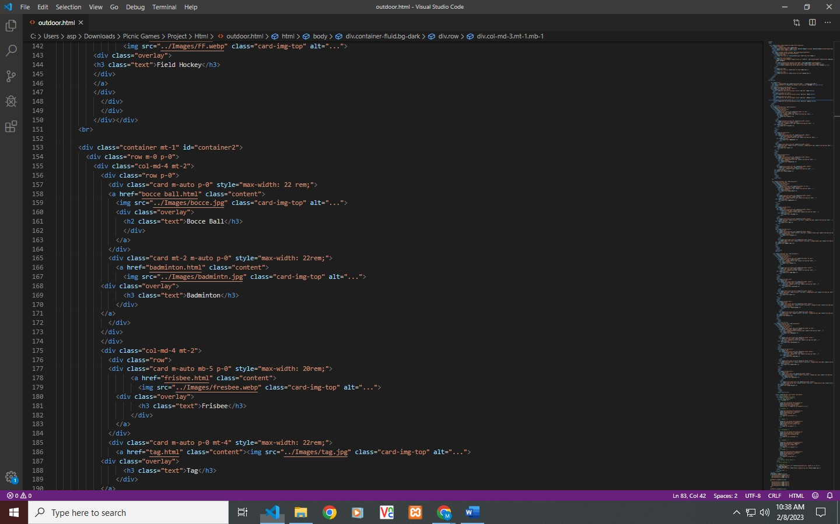

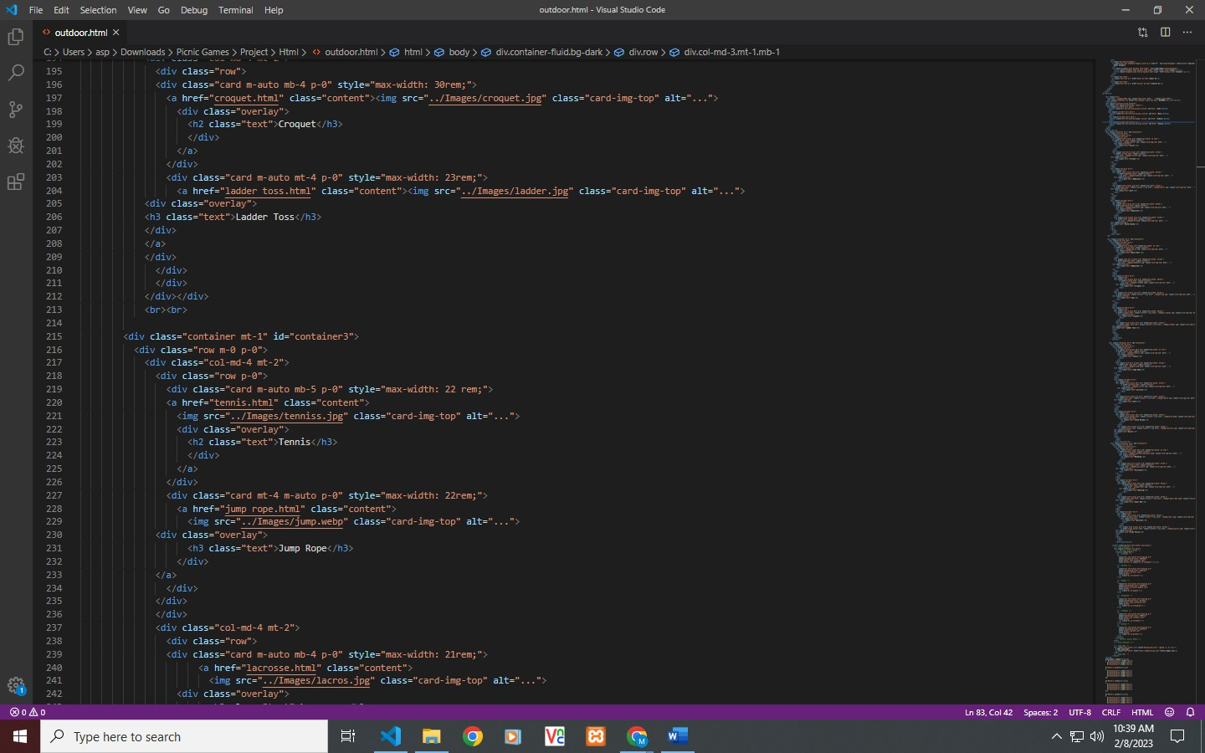

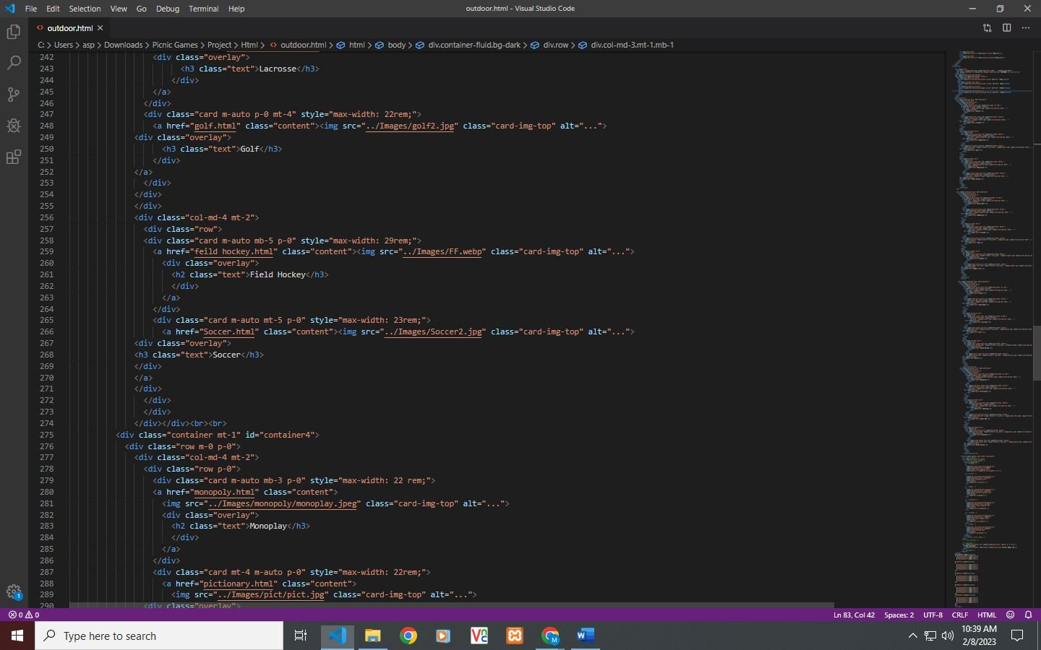

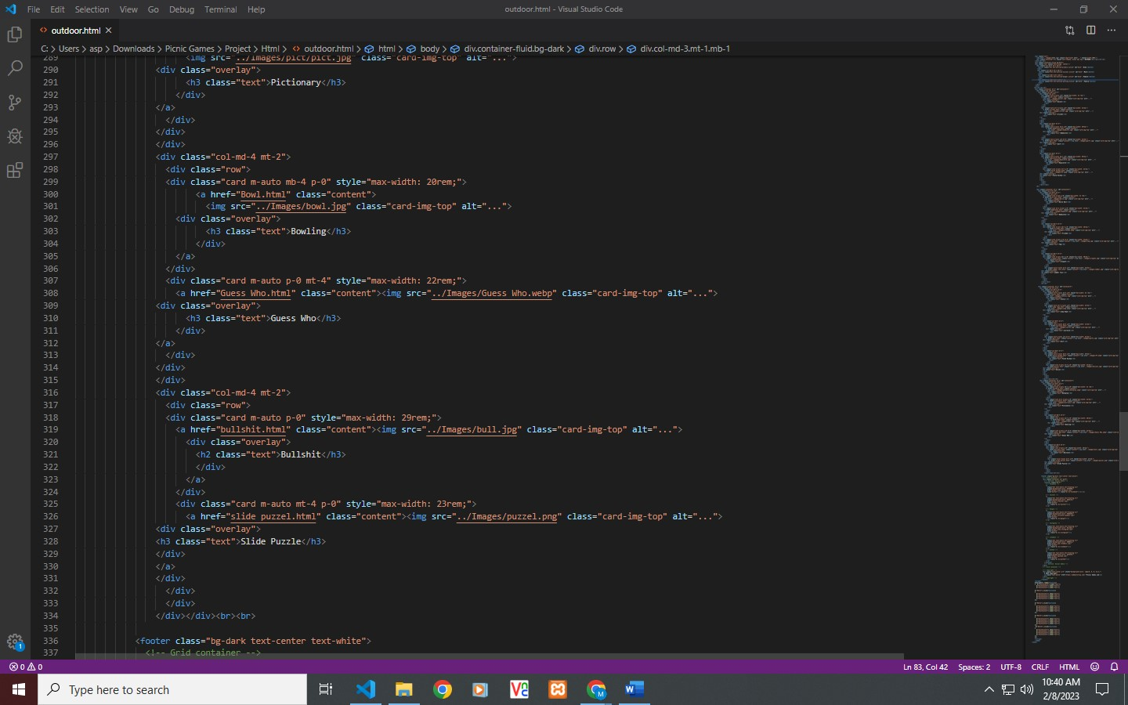

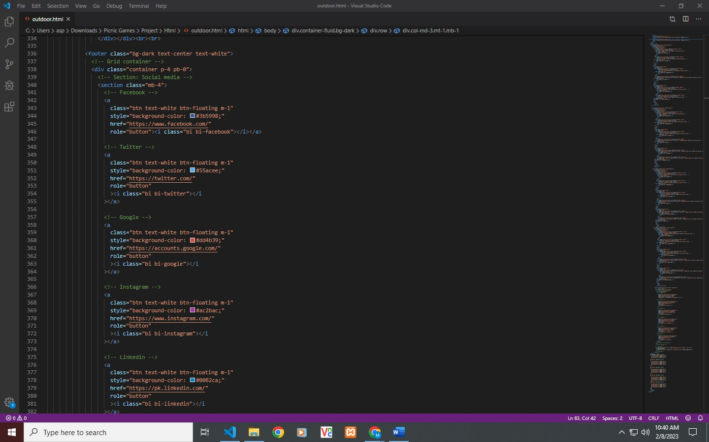

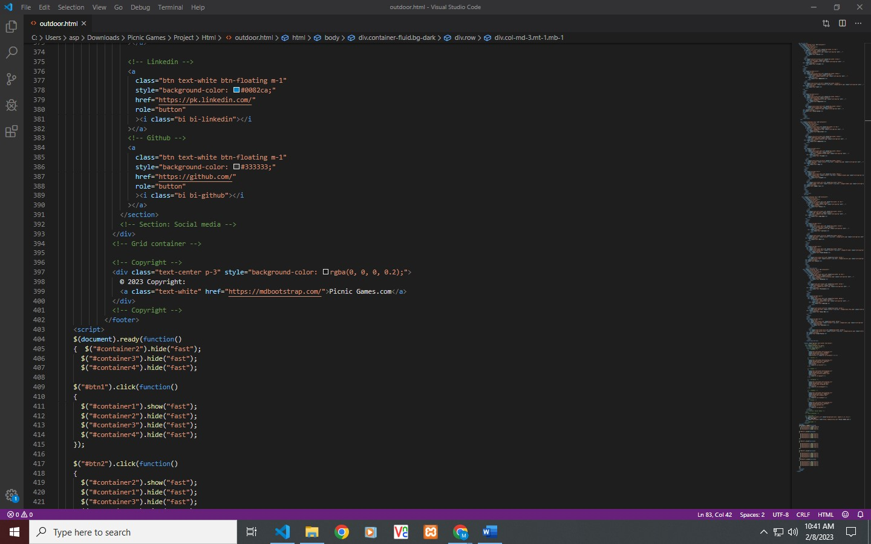

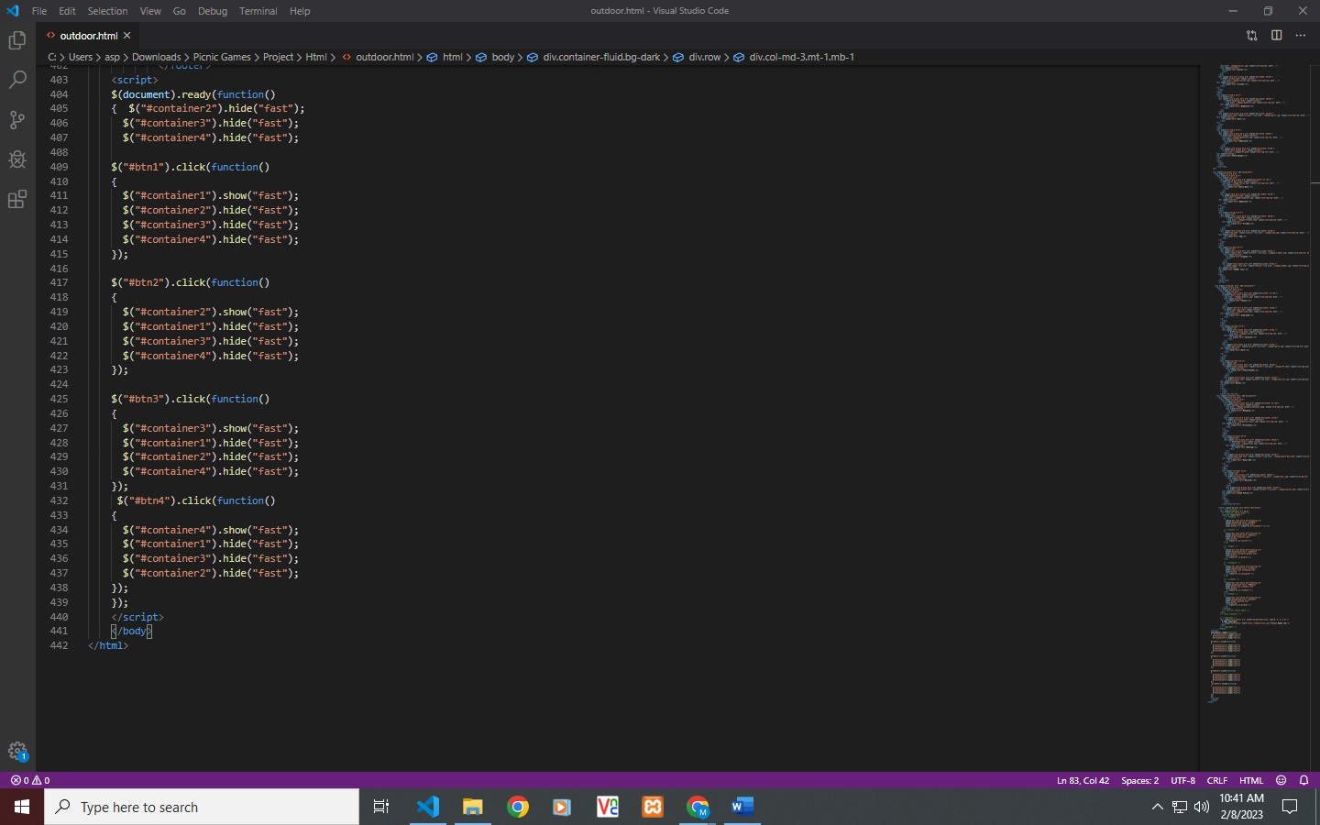

**Map**

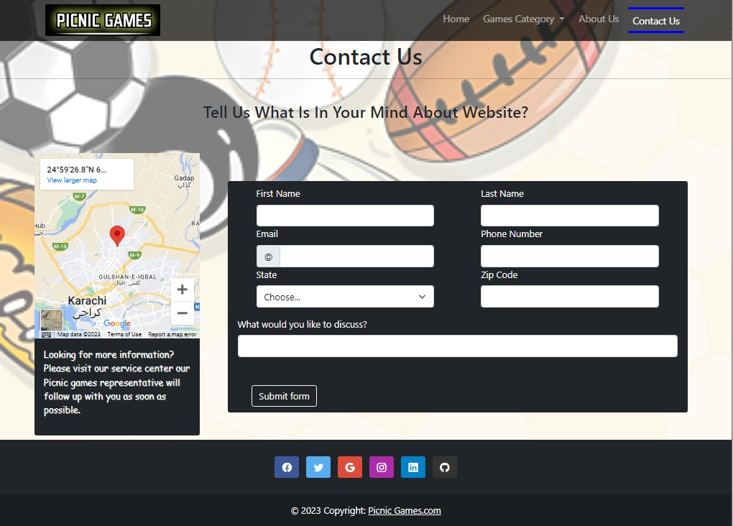

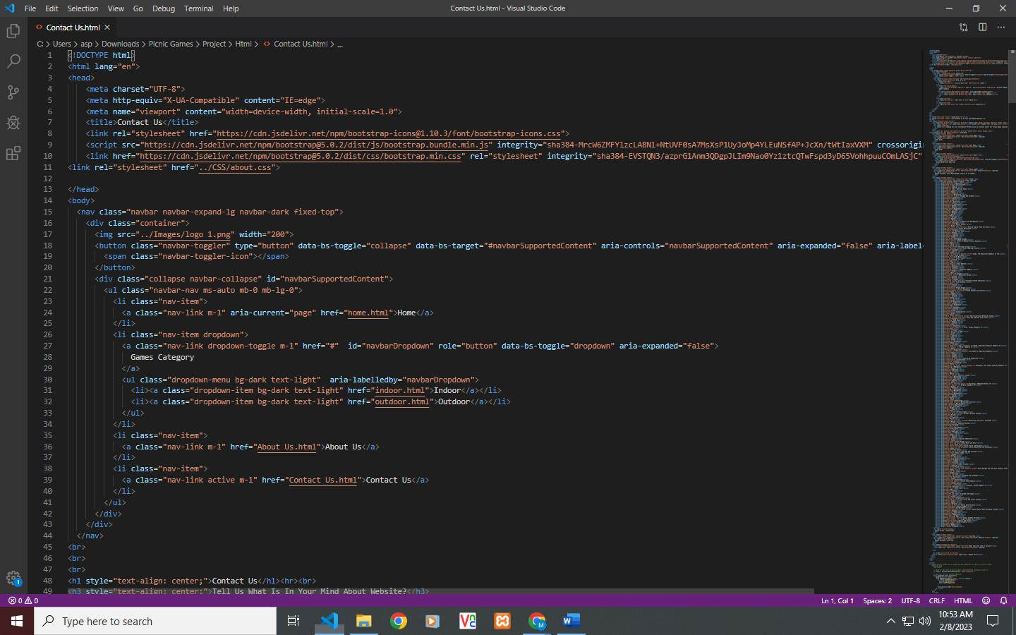

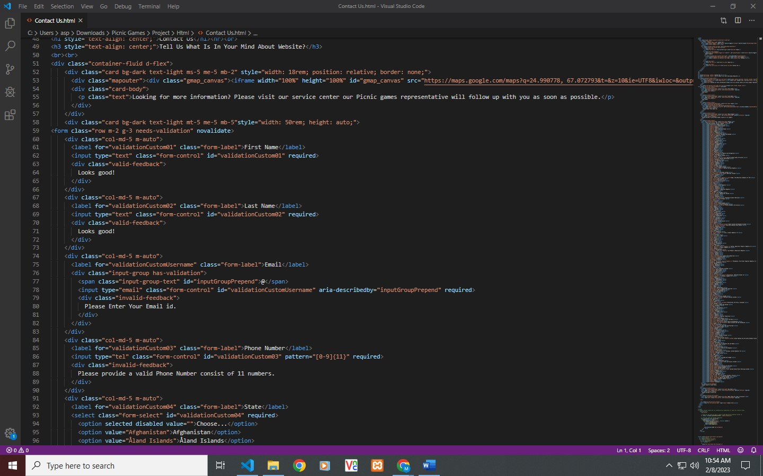

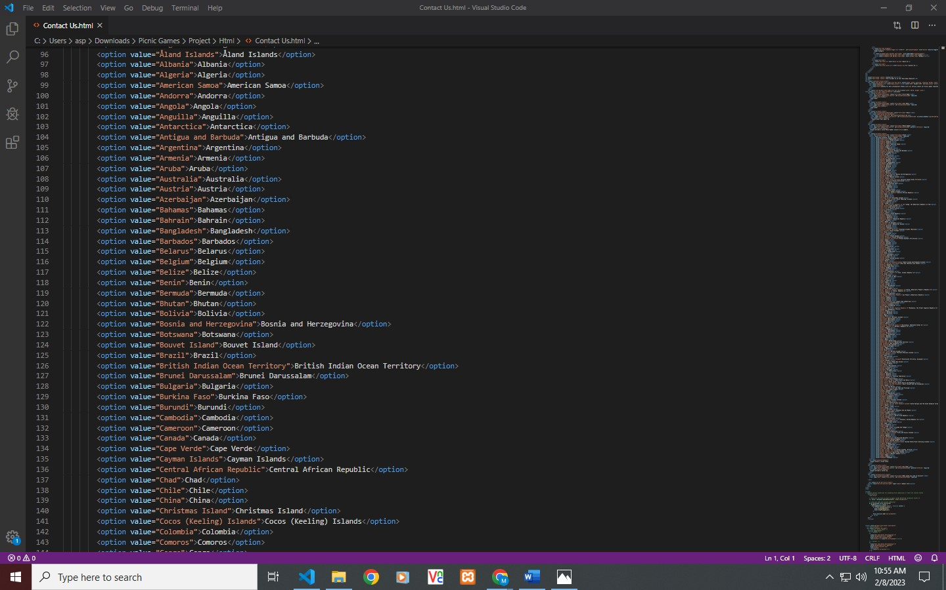

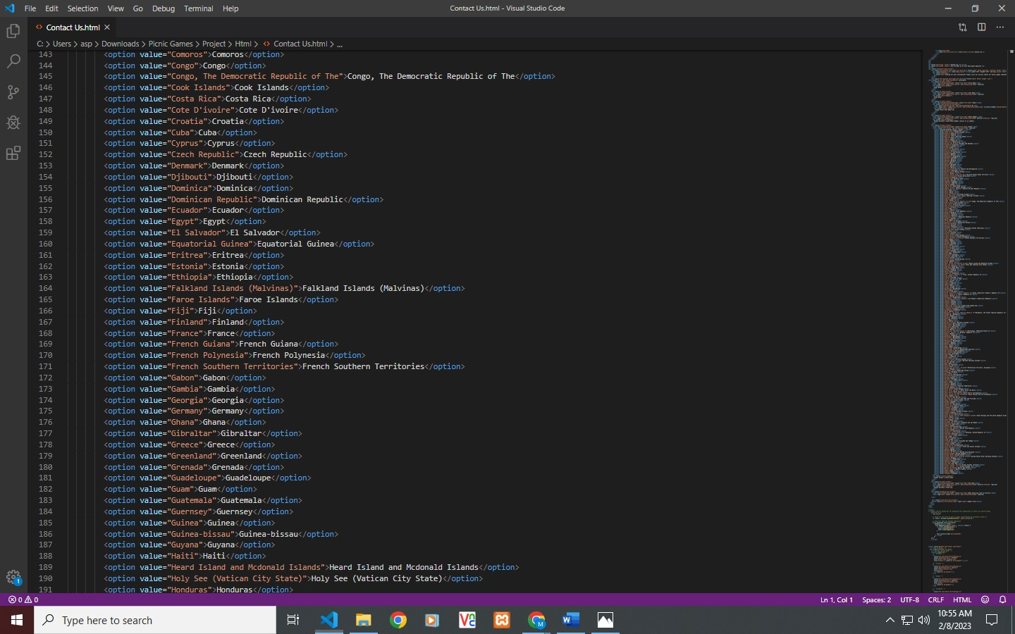

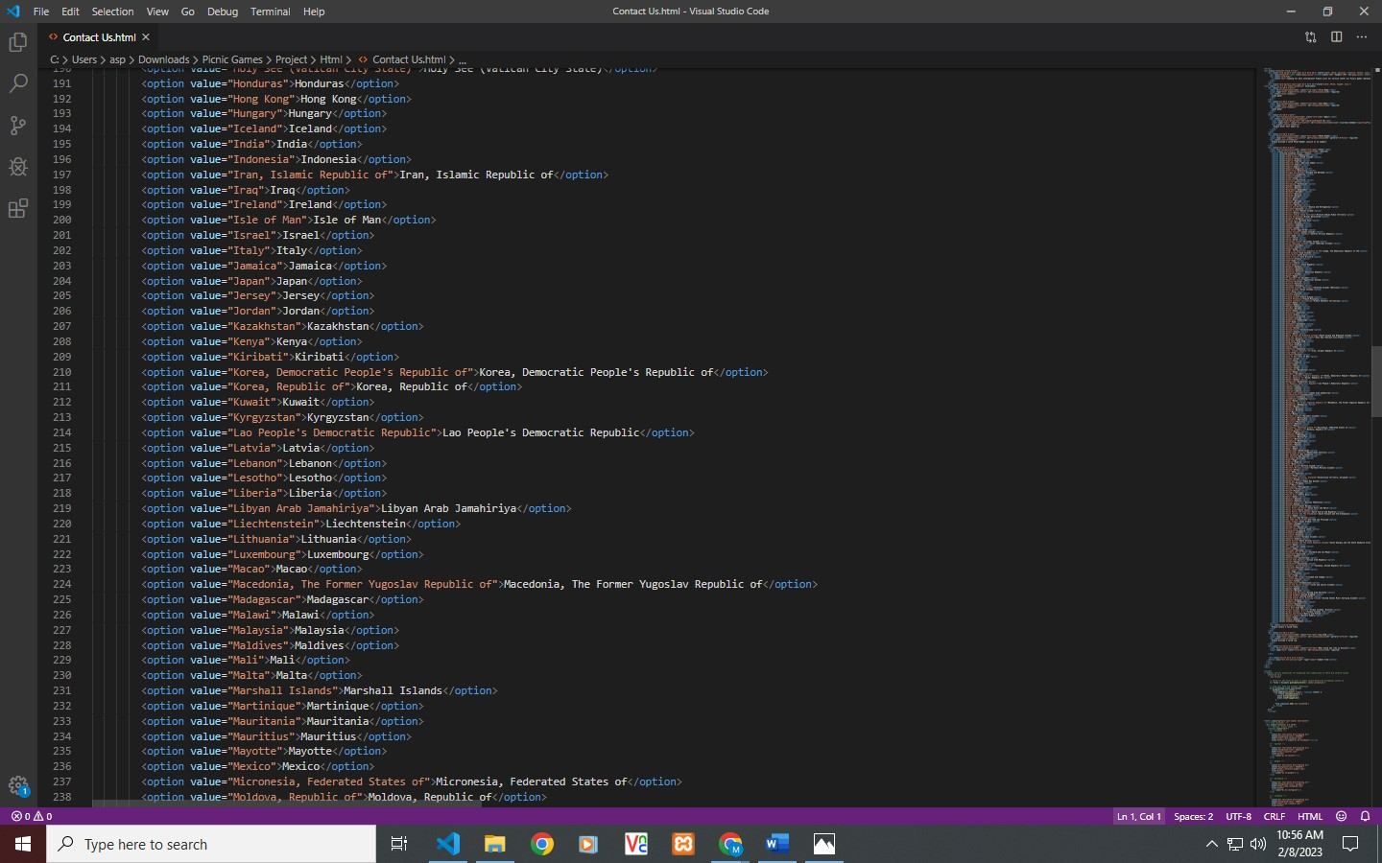

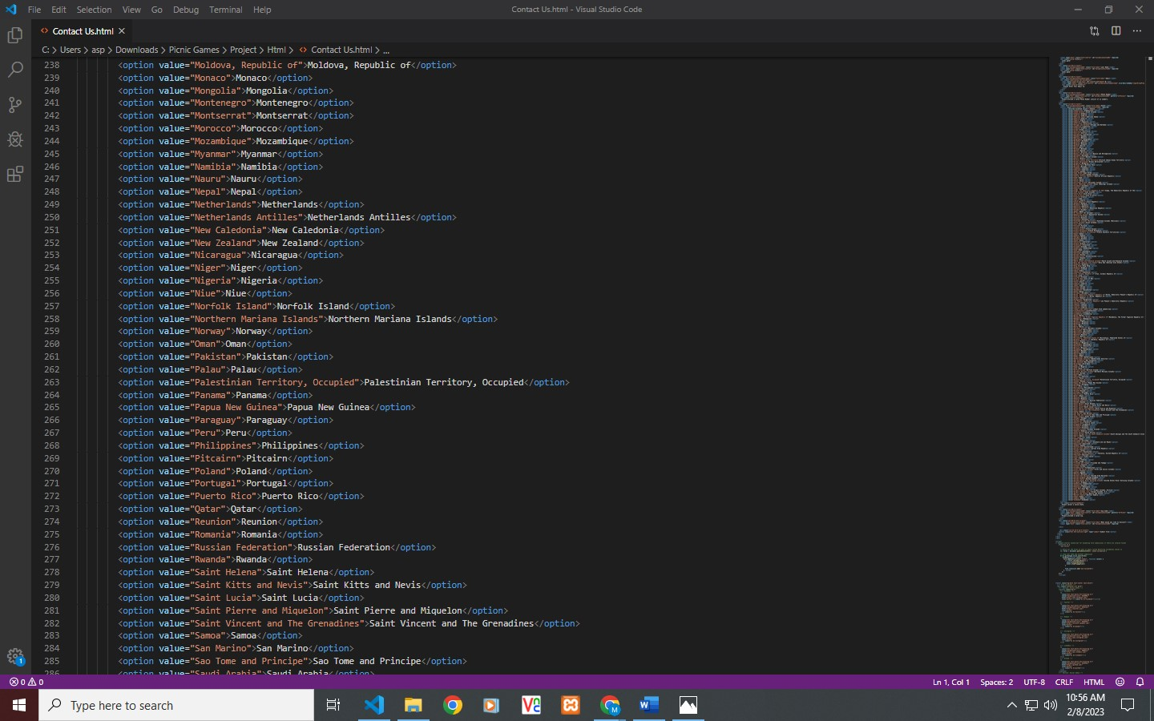

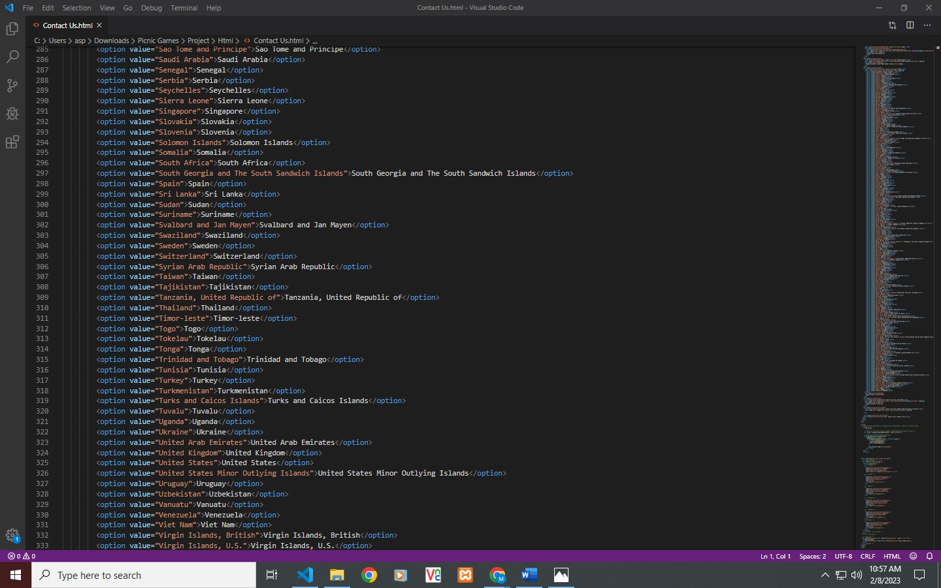

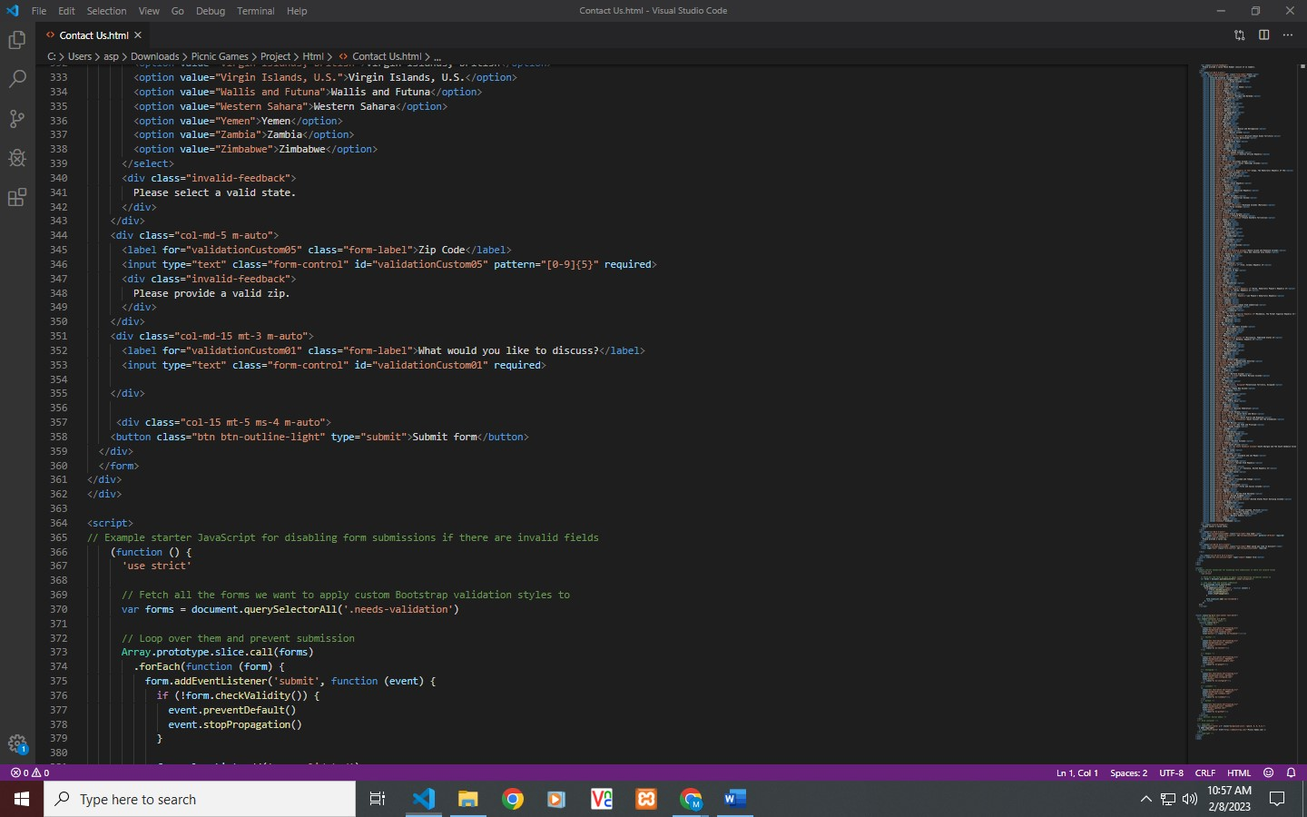

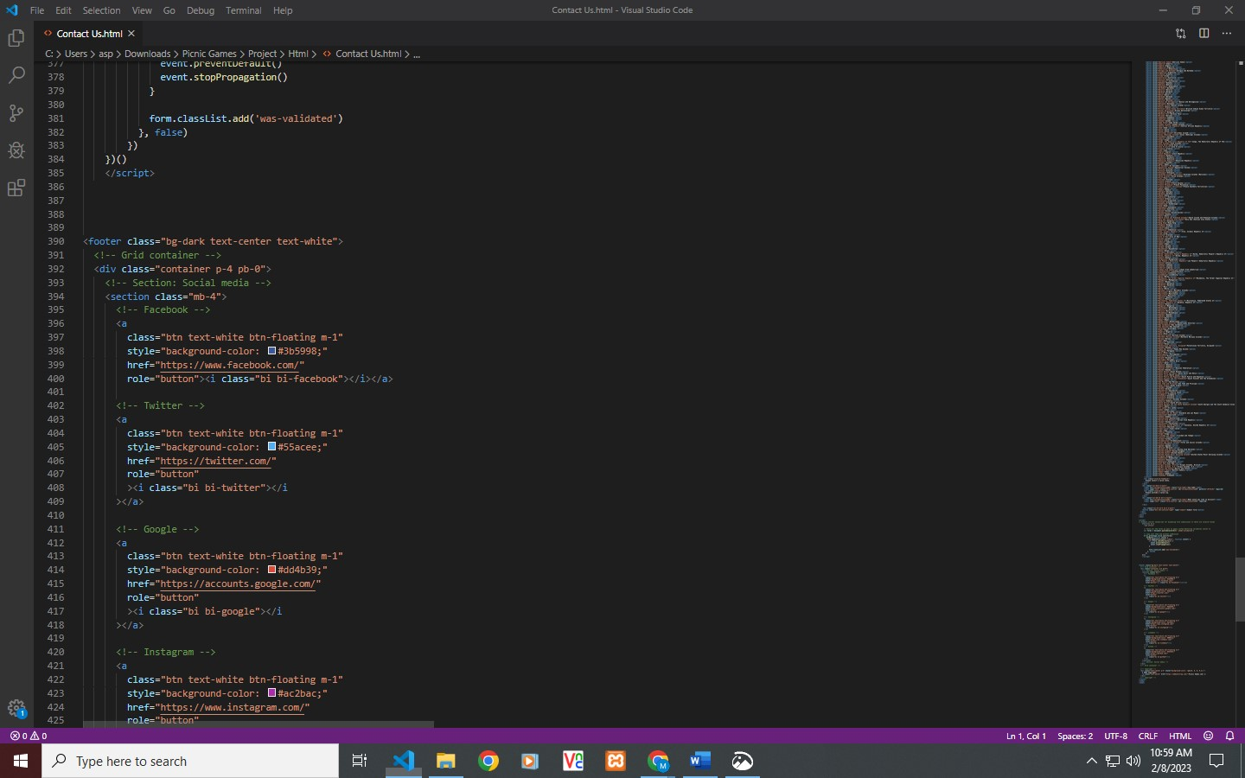

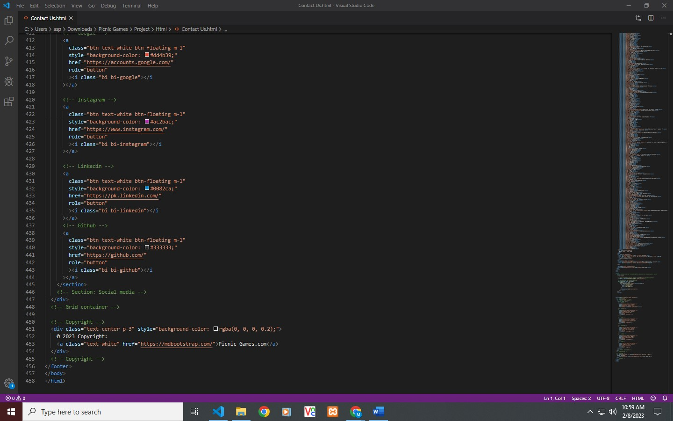

**TASK SHEET REVIEW 2**

|  |  |  |  |  |  |  |
| --- | --- | --- | --- | --- | --- | --- |
| Project Ref. No.: eP/Advertisement Portal Management System/01 | | Project  title | Date of Preparation of Activity Plan | | | |
| No | Task | Picnic Games | Actual | Actual | Team-mate | Status |
| Start Date | Days | Names |
| 1 | Navbar | 9/JAN/2023 | 1 | ABDULLAH SHAHZAD | Complete |
| 2 | Main Body Navbar | 10/JAN/2023 | 2 | ABDULLAH SHAHZAD | Complete |
| 3 | Footer | 12/JAN/2023 | 1 | ABDULLAH SHAHZAD | Complete |
| 4 | Home | 16/JAN/2023 | 4 | MUHAMMAD ALEEM | Complete |
| 5 | Instruction Page | 20/JAN/2023 | 4 | MUHAMMAD ALEEM | Complete |
| 6 | Indoor Games | 24/JAN/2023 | 4 | MUHAMMAD ALEEM | Complete |
| 7 | Outdoor Games | 28/JAN/2023 | 4 | RAGHIB RIZWAN RABANI | Complete |

**TASK SHEET REVIEW 3**

|  |  |  |  |  |  |  |
| --- | --- | --- | --- | --- | --- | --- |
| Project Ref. No.: eP/Advertisement Portal Management System/01 | | Project title | Date of Preparation of Activity Plan | | | |
| No | Task | Picnic Games | Actual  Start Date | Actual  Days | Team-mate  Names | Status |
| 1 | Kids | 30/JAN/2023 | 3 | MUHAMMAD UMAIR | Complete |
| 2 | Family | 2/FEB/2023 | 3 | MUHAMMAD UMAIR | Complete |
| 3 | Male | 5/FEB/23 | 3 | HARIB UDDIN | Complete |
| 4 | Female | 6/FEB/23 | 3 | ABDULLAH SHAHZAD | Complete |
| 5 | J query and JavaScript |  | 7/FEB/23 | 2 | MUHAMMAD ALEEM | Complete |